Instructors: DR.Vineet Dubey

internet

16 April 2023

ROBOTIC HAND WITH MUSCLE SENSOR

Abstract:

Robotic hands with muscle sensors are one of the emerging areas of research in the field of robotics. This technology allows for intuitive and natural control of robotic hands, enabling them to perform complex tasks that were previously only possible with human hands. In this paper, we will explore the current state of research in this area, including the design and implementation of muscle sensors for robotic hands, the methods used to interpret the signals produced by these sensors, and the potential applications of this technology in various fields.

INTRODUTION:

The development of robotic hands with muscle sensors has been driven by the need for more intuitive and natural interfaces between humans and machines. Traditional robotic hands have been controlled using complex algorithms and specialised software, which can be difficult for humans to master. By using muscle sensors, which detect the electrical signals produced by muscle contractions, robotic hands can be controlled in a way that is similar to how humans control their own hands.

DESIGN AND IMPLEMENTATION OF MUSCLE SENSOR:

Muscle sensors for robotic hands can be designed using a variety of technologies, including electromyography (EMG) sensors and capacitive sensors. EMG sensors detect the electrical signals produced by muscle contractions, while capacitive sensors measure the changes in electrical properties of the skin that occur when muscles are flexed. These sensors can be integrated into the robotic hand in a variety of ways, including attaching them to the skin using adhesive patches or embedding them directly into the hand's surface.

INTERPRETATION OF MUSCLE SENSOR SIGNALS:

The signals produced by muscle sensors must be interpreted in order to control the movements of the robotic hand. This can be done using a variety of signal processing techniques, including pattern recognition algorithms and machine learning algorithms. These techniques analyse the signals produced by the muscle sensors and use this information to control the movements of the robotic hand.

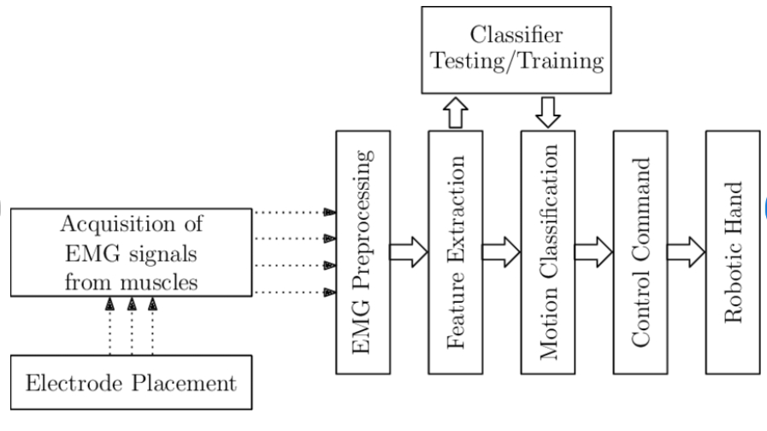

Flow chart of actuating robotic hand by sEMG signals

APPLICATIONS OF ROBOTIC HANDS WITH MUSCLE SENSOR:

Robotic hands with muscle sensors have a wide range of potential applications in various fields. For example, they could be used in the field of medicine to control surgical robots during minimally invasive procedures. They could also be used in the field of prosthetics to provide amputees with more natural and intuitive control over their prosthetic limbs. In the field of manufacturing, robotic hands with muscle sensors could be used to perform delicate tasks that require a high degree of precision.

Conclusion:

Robotic hands with muscle sensors represent a significant advancement in the field of robotics, providing a more intuitive and natural interface between humans and machines. The design and implementation of muscle sensors for robotic hands, the interpretation of muscle sensor signals, and the potential applications of this technology in various fields are all areas of active research. As this technology continues to develop, it has the potential to revolutionise the way that humans interact with machines.